The King’s College London Georgian Papers Programme Mount Vernon Fellowship 2020-21
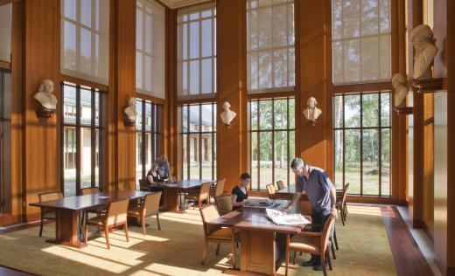
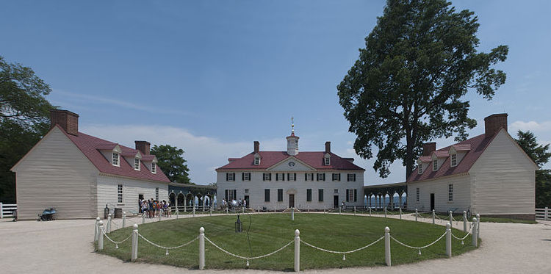
Image: David Samuel
The Georgian Papers Programme at King’s College London invites applications for the King’s College London Mount Vernon Fellowship for 2020-21.
The King’s College Mount Vernon Fellowship allows a scholar to pursue research and writing in the Washington Library at Mount Vernon for a period of one month, or in exceptional circumstances up to two months. The fellowship supports travel and living expenses of the recipient. For the duration of the fellowship the recipient will reside in the Washington Library’s scholars’ residence at Mount Vernon and have full use of the extensive facilities. The fellow will be expected to carry out a programme of research or writing specified in the application. In making an award, priority will be given to research aligned with the mission of the Washington Library and the Georgian Papers Programme, but applications will be considered from all those whose research could benefit from the residency, and the opportunities for scholarly exchange and collaboration that residency at Mount Vernon would make possible. Applications can be considered from any scholar employed by King’s College London or current PhD student, regardless of departmental or faculty affiliation, and from scholars associated with the Georgian Papers Programme at King’s as Summer Fellows; where applications are of equal merit, preference will normally be given to King’s candidates. Timing details of the residency at Mount Vernon can be decided between the Fellow and the Washington Library once an award has been made. Other details regarding the arrangements and funding are in the further particulars.
To apply, please fill out the application form below, and send it with a CV and statement of proposed research of no more than 1,000 words to Professor Arthur Burns, Academic Director of the Georgian Papers Programme at King’s College London (arthur.burns@kcl.ac.uk) by 20 May 2020.
Mount Vernon and the Fred W. Smith National Library for the Study of George Washington
Mount Vernon, situated on the Potomac River in Fairfax County, Virginia, some 15 miles south of the centre of Washington DC, was the plantation home of George and Martha Washington, who are both buried there. One of the most important historic sites in the United States, and maintained in trust by the Mount Vernon Ladies’ Association (MVLA), the estate attracts more than a million visitors each year.
The estate is also home to the Fred W. Smith National Library for the Study of George Washington, opened in 2013 to advance appreciation and understanding of the first president of the United States. The Library houses Washington’s books and manuscripts, a further 1,500 eighteenth-century volumes, and a large collection of nineteenth-century newspapers, manuscripts, and documents. It is also a scholarly retreat and offers educational outreach, seminars and training programs with a special focus on Washington’s leadership. Further information about the library can be found here.
In 2015 the Washington Library inaugurated a new academic partnership with King’s College London in support of the Georgian Papers Programme thanks to the generous support of the Amanda and Greg Gregory Family Fund. Three Mount Vernon fellows have already visited Britain through the programme: Bruce Ragsdale, researching the agricultural interests of George Washington and George III, Flora Fraser, biographer of George and Martha Washington, and Zara Anashanslin, researching material culture. King’s College London is extremely grateful to the Washington Library for helping to make this exciting academic opportunity possible.

The Georgian Papers Programme
On 1 April 2015 the Georgian Papers Programme was launched at Windsor Castle in the presence of Her Majesty, Queen Elizabeth II. This innovative collaboration between King's College London and the Royal Collection Trust, a charitable arm of the Royal Household, will by 2020 digitize and make freely available to a global public the Royal Archives held in the Round Tower at Windsor Castle which pertain to the reigns of the Hanoverian monarchs from George I to William IV. These archives provide the opportunity for a major scholarly reappraisal of many key aspects of the history of the period, containing as they do an extraordinarily rich collection including correspondence, maps and royal household ledgers pertaining to every aspect of the royal family’s extensive engagement with both the domestic (in every sense) and the global Georgian world. The documents already released are already available here. King’s College London is leading the academic interpretation supporting the project in close collaboration with a growing number of institutions and organizations equally committed to serious but publicly accessible study of the period including, alongside Mount Vernon, the Omohundro Institute of Early American History and Culture; the College of William and Mary, Williamsburg; the Library of Congress; and the Sons of the American Revolution. The next few years will see an extensive programme of research, public events and online publication: for current activity please see the Georgian Papers website. In 2022 there will be a major exhibition at the Library of Congress in association with the programme.

The King’s College London Georgian Papers Programme Mount Vernon Fellowship 2020-21
Application Form

Full name and title: _____________________________________

Email address:

Contact phone number:

King’s College London department and faculty:

Title of proposed research/writing project: ____________________________________

Scholarly publications/other outputs anticipated to arise /benefit from the proposed research:

Indication of preferred timing for residency at Mount Vernon:

Please confirm that you are eligible to travel to the United States from the UK in order to conduct academic research ☐

Signature:
Date:

Please email the completed form, together with
- A CV
- A statement of not more than 1.000 words of the intended research/writing, including an account of how residency at Mount Vernon would help forward the project; what use if any you would make of the holdings at the library; and intended outcomes
to Professor Arthur Burns ( Arthur.burns@kcl.ac.uk ) with the subject line ‘Mount Vernon Fellowship [surname of applicant] by 20 May 2020.

This is indicative only: actual timings must be agreed with the Washington Library. The dates should fall within the period ending 31 August 2021. All timings are currently provisional in light of the uncertainty relating to the reopenjng of the Washington Library during the Covid-19 pandemic. Candidates will be kept informed of any new information relating to reopening.

